**Abstract**

When researching the self-driving car industry, a variety of approaches have been used to try to reach the end goal of fully autonomous vehicles. Elon Musk and Tesla take the approach of computer vision and object detection, while deploying the technology to a mass amount of people as the technology develops, while Waymo takes the approach of developing and perfecting their LiDar technology by testing it in different cities and expanding slowly. The two different technologies are polar opposite approaches to solving the same issue, and we are yet to see who will reach the finish line first. However, we believe that Waymo’s approach is safer, uses better technology and is the better approach to the problem moving forward.

# **Introduction**

# The race towards fully automated self driving cars has been heating up in the last decade, with large companies like Tesla and Waymo attempting to push the boundaries of what we know to be possible in the industry. The possible benefits of autonomous vehicles are vast, including increased safety, improved traffic flow, and reduced environmental impact. However, there are still significant challenges to be overcome before this technology can become a widespread reality. In particular, there are ongoing debates about the best approach to achieving full automation, with Tesla and Waymo taking very different approaches.

Tesla's approach to self-driving technology is centered around computer vision and object detection. They aim to deploy this technology to a large number of people as the technology develops, with the goal of eventually achieving full autonomy. On the other hand, Waymo has focused on perfecting their LiDar technology through extensive testing in different cities, with a slower approach to expansion. Both companies have made significant progress, but the question remains: which approach is more effective? In this paper, we compare the two technologies and argue that Waymo's approach is superior, providing better safety and more advanced technology.

## **Self-Driving Car Industry**

The goal of the self driving car industry is to eventually reach the point of fully autonomous driving. There are five levels to describe how close a car is to fully self-driving, ranging from 0 (fully manual) to 5 (fully autonomous).

1. **Level 0** (No Driving Automation)

This level represents the majority of cars on the road today, which are manually controlled. The human at the wheel is in full control of the vehicle.

1. **Level 1** (Driver Assistance)

The next step up from completely manual is the addition of cruise control, and the vehicle will usually feature a single automated system.

1. **Level 2** (Partial Driving Automation)

The vehicle is able to control both steering and

accelerating and decelerating.

1. **Level 3** (Conditional Driving Automation)

Vehicles are able to make decisions about the environment on their own.

1. **Level 4** (High Driving Automation)

Vehicles can not only detect the environment around them but also intervene if things go wrong or if there is a system failure.

1. **Level 5** (Full Driving Automation)

The final level of automation does not require any human attention, and can operate completely on its own.

According to Automotive World (2022), “ The end goal of Level 5 is for every vehicle on the road to be fully automated. There are currently no public examples of Level 5 (full automation). There’s still debate over when full automation will be a reality, but the industry is taking steps to get there, and this could happen within the next decade depending on progress.

*[Figure 1- 5 Stages of Autonomous Vehicles]*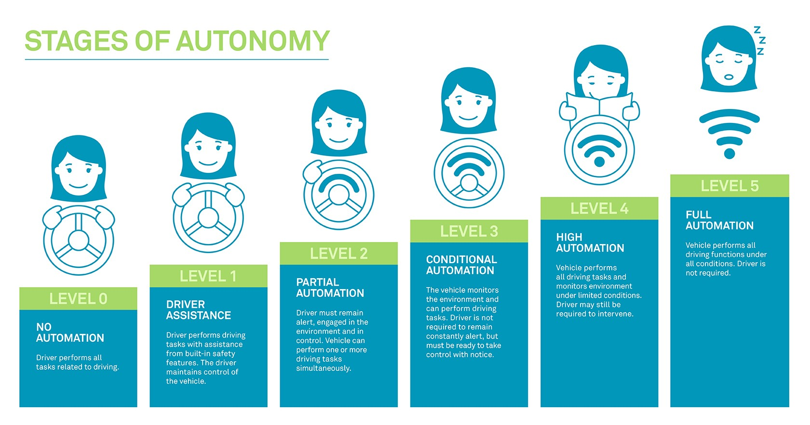

**Benefits of Automation**

If level 5 automation can be safely and successfully attained, the benefits for public safety are extensive. Some of the main benefits include safety with less crashes on the road, which can also reduce costs of medical bills from crashes, reduced traffic congestion leading to reduced greenhouse gasses from cars sitting in traffic, and productivity as riders can use time in the vehicle for other tasks instead of focusing on the road.

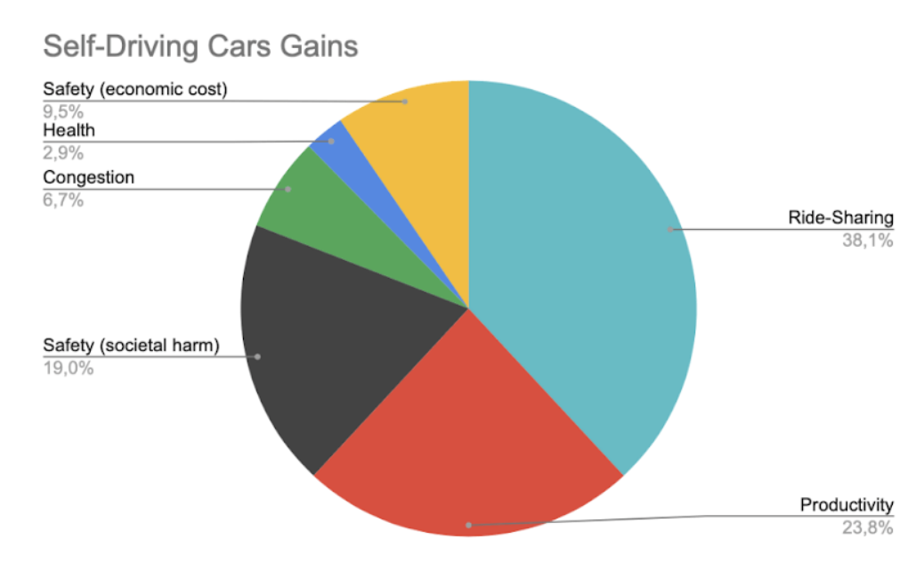

*[Figure 2- Benefits of Self Driving Cars]*

MIT researcher Emilio Fazzoli said that he believes one of the biggest benefits from autonomous vehicles will be its potential ride-sharing services, and used Figure 2 to visualize what he believes will be the biggest benefits from autonomous vehicles (Fridman, 2018). Instead of owning a car or taking public transportation, people could simply use a ride-sharing service to get to their destination, reducing the number of cars on the road and potentially reducing traffic congestion. This could have a significant positive impact on the environment and public health, while also reducing the cost and stress associated with car ownership. Furthermore, ride-sharing services could provide an affordable and convenient transportation option for people who may not have access to a car or public transportation.

Another major benefit of autonomous vehicles is improved accessibility for individuals who may have difficulty driving or using public transportation, such as the elderly or people with disabilities. Self-driving cars can provide these individuals with increased mobility and independence, allowing them to travel to appointments, visit family and friends, and participate in activities they may not have been able to before. This can have a significant positive impact on their quality of life and overall well-being.

The benefits of level 5 automation in the self-driving car industry are extensive and have the potential to revolutionize the way we think about transportation. With increased safety on the road, reduced traffic congestion, improved productivity and accessibility, and the potential for innovative ride-sharing services, self-driving cars have the potential to positively impact individuals and society as a whole.

**Goal of the Industry**

According to Mallika Rangaiah with Analytics Steps publication, “the goal is to integrate advanced control systems in the vehicles, so that the sensory inputs can be interpreted for detecting signboards and steering clear of collisions.” This shows that the overall goal of the industry is full automation but also has a major emphasis on safety for both people and objects to move around. If any company is able to reach a Level 5 fully autonomous vehicle, there is an extremely large financial incentive, as 60% of Americans say they would use an Autonomous vehicle if given the chance (Pew Research).

The goal for these companies is not just to succeed in their technological pursuits, but also to achieve the benefits previously mentioned. There is certainly a race between Tesla, Waymo, and many others to see who can advance their strategy the fastest, but all recognize the collective societal benefits which drive the race.

## **2. Technology Overview**

**2.1 Tesla**

Tesla was founded in 2003 with the goal of moving forward the mission of making sustainable energy more proactive throughout the world. The company kickstarted their mission with their first product being released in 2008, the Roadster sports car, and has evolved proactively in the past decade (Tesla, n.d.). Tesla utilizes unsupervised machine learning AI technologies which provides the self driving algorithm within the vehicles. The main AI technologies within the vehicles are as follows: AI integrated chips, autopilot, 360-degree visualization, and the batteries and propulsion system (“Artificial Intelligence in Tesla Vehicles”, n.d.).

Essentially, the AI integrated chips allow the vehicles to move throughout freeways and traffic. “*Approximately 6 billion transistors constitute the circuit of each Tesla chip. These Tesla chips are 21 times faster than the original Nvidia chips and 20% cheaper too. They have 32 megabytes of high-speed SRAM memory on the chip because of which fetching data is faster and easier compared to DRAM* (“Artificial Intelligence in Tesla Vehicles”, n.d.).” These vehicles don’t only have one AI chip, but each contain two AI chips. The chips perform two complete different tasks while assessing traffic and any dangerous situations surrounding the vehicle. When the assessments are made by the separate AI chips, they are matched together to allow the vehicle to be guided according to the outputs of the assessments. With the vehicle having not one, but two AI chips, more controlled navigation is allowed throughout the product.

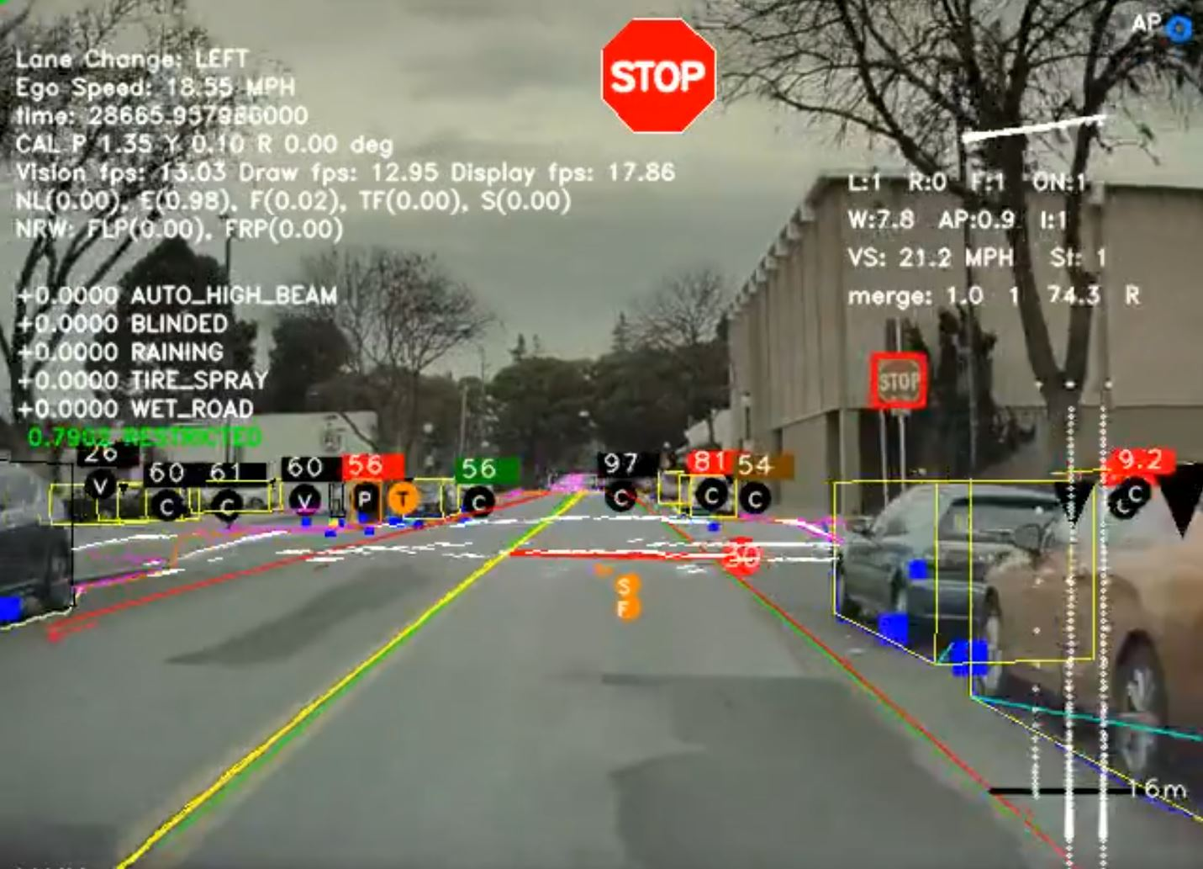

*[Figure 3- Visual of Tesla Computer Vision]*

The next important AI feature within the Tesla vehicles is autopilot. “*Autopilot features enable cars to steer, accelerate, and brake automatically in the lane. All new Tesla cars since 2016 come with Autopilot which includes Traffic-Aware Cruise Control and Autosteer features (“*Artificial Intelligence in Tesla Vehicles*”, n.d.).”* The autopilot focuses on the basis of deep neural networks through the use of cameras, ultrasonic sensors, and radar. Utilizing these features allows an awareness to be gained of what is around the vehicle and where it is located on the road itself. There are many different challenges which can surround the vehicle in specific situations depending on different lighting and weather conditions. In order to combat these differing scenarios, radar is utilized throughout the vehicle. It is important to note that autopilot within Tesla vehicles does require assistance from the driver and does not mean Tesla vehicles are fully self-driving or autonomous. If the driver of the vehicle removes their hands from the steering wheel, they are continuously notified to keep their hands on the wheel. If the driver does not put their hands on the wheel within a certain amount of time/warnings, the vehicle will begin to slow down and eventually come to a full stop as a safety precaution. In addition, the autopilot features can always be overridden by the driver when needed (“Artificial Intelligence in Tesla Vehicles”, n.d.).

Another AI feature utilized by Tesla vehicles is 360-degree visualization. *“Tesla cars use a neural network to process 8 cameras placed in the system. They provide a 360-degree visualization of surrounding vehicles up to 250 meters. These cameras provide a deeper understanding of objects around the automobile by giving access to views from different angles thus enabling a safer drive. Twelve updated ultrasonic sensors improve the vision by detecting both updated and soft objects around the vehicle (*“Artificial Intelligence in Tesla Vehicles”, n.d.*).”* Essentially, the neural network allows the vehicle to interpret the visualizations from around the vehicle in a wholesome manner to utilize the best safety methods possible.

The last important AI feature which contributes to the technology behind the vehicle is the batteries and propulsion system. Tesla vehicles contain lithium-ion batteries, which allow for a larger amount of energy density than different batteries which are used by companies for other battery-electric vehicles. In addition to lithium-ion batteries, Tesla vehicles contain electric motors consisting of two moving parts and single-speed transmissions. These transmissions do not contain any gears and have drivetrains consisting of 17 moving parts (“Artificial Intelligence in Tesla Vehicles”, n.d.).

Along with all of the AI technologies within the Tesla vehicles, Tesla has a competitive advantage over their competitors in that they utilize all existing data which comes from the large amount of Tesla vehicles which are driving anywhere in the world currently. Not only is data collection performed involving the performance and actions of the vehicles themselves, but data is also collected on the basis of driver behavior. This approach that Tesla has taken within its vehicles is known as ‘imitation learning.’ “Their tracking system is incredibly sophisticated. For example, when a Tesla vehicle makes an incorrect prediction about the behaviors of a car or cyclist, Tesla saves a data snapshot of that moment, adds it to the data set, then reproduces an abstract representation of the scene with color coded shapes that the neural networks can learn from (Bernard, 2021).”

Now that we have discussed the technology and process behind the AI technology utilized by Tesla, we want to dive deeper into the algorithms within the autopilot system. Tesla has a focus of five main algorithms utilized for different aspects within their vehicles. The main algorithms used by the company are convolutional neural networks to recognize and classify images, object detection to see and track objects, such as cars, pedestrians, and other vehicles, within the field of vision of the vehicle, optical flow to make estimations and predict how objects will move, lane detection to detect the lanes within the roads, and semantic segmentation to segment the images into separate regions (Mishra, n.d.). Through the combination of the algorithms utilized by Tesla, the company has an opportunity to continue building an empire and eventually create a fully autonomous vehicle made available for the public.

Tesla’s autonomous vehicles have proven to make a name for themselves with the enhancement and utilization of AI technology. Combining all of the technology together, Tesla has a unique advantage over competitors, but is the advantage enough to be the greatest company within the realm of autonomous vehicles? Tesla’s self-driving vehicles are limited in capabilities when compared to other self-driving cars in the market. What truly sets them apart is the amount of cars made available to the public, along with the capabilities/limits of the vehicles. While Tesla provides vehicles that have less capability but more availability, Waymo provides more capable self-driving cars, but are available to a smaller number of people (Cohen, 2021). This is something that will be further explained after analysis of Tesla’s biggest competitor, Waymo.

## **2.2 Waymo**

Google’s self-driving technology company, later renamed Waymo, was kickstarted in 2009. Its mission is *“to make it safe and easy for people and things to get where they’re going”* (Waymo, n.d.)*.* Their flagship product is the Waymo Driver, an autonomous driving system that utilizes *“360-degree perception technology [allowing] it to identify obstacles like pedestrians, other vehicles, or any construction work from up to several hundred yards away”* (Rangaiah, 2021)*.* Waymo has partnered with many car manufacturers (Jaguar Land Rover and Volvo, to name a few) to integrate its self-driving technology into their vehicles, however Waymo Driver can be applied to a number of different vehicles. Whether minivans, SUVs, Class 8 trucks, etc. It can also be implemented into numerous vehicles and across a variety of experiences, such as ride-hailing, trucking, and local delivery. They have also partnered with original equipment manufacturers to expose their product to more places and people, across a variety of vehicle forms, from passenger to commercial vehicles. Waymo Driver currently offers two services: Waymo One and Waymo Via. Waymo One uses the autonomous driving system as a ride-hailing service, helping people in the Metro Phoenix and San Francisco areas get to and from their destinations. Waymo Via uses the technology to transport commercial goods, with an emphasis on improving safety and increasing efficiency, while the local delivery solution is designed to revolutionize the last-mile experience. The product they offer is ground-breaking in the autonomous driving industry, but how does it work?

To get an idea of how Waymo Driver operates, it is best to first have an understanding of the data they have collected. Waymo themselves have stated that, *“with millions of miles driven through countless situations on public roads, and billions more in simulation, we’ve gathered incredible amounts of data and invaluable lessons to develop autonomous driving technology further than anyone else”* (Waymo, n.d.)*.* They boast that their product has 20+ million miles on public roads and 20+ billion miles in simulation experience, all tested across 13+ states in the US. This massive data collection alludes to the process of how Waymo Driver works, which they lay out in a four step process: 1) Mapping out every intersection, sign, and signal, 2) Keeping an eye on everything, all at once, 3) Predicting things before they happen, and 4) Planning the safest outcome (Waymo, n.d.).

The first step of the process requires a lot of preplanning, as it entails mapping out an entire new area in incredible detail before Waymo Driver begins operating in the area. The new territory is mapped down to the minute details, from lane markers to stop signs to curbs and crosswalks. By doing so, Waymo Driver can use these complex, custom maps in conjunction with real-time sensor data to determine its exact location at all times, rather than relying on external data, such as GPS which can lose signal strength.

Step two--keeping an eye on everything, all at once--regards Waymo Driver’s perception system, which utilizes its immense repertoire of technology (which we will touch more on in a bit) to decipher what is going on around it. Whether it be pedestrians, cyclists, vehicles, construction, and signs or signals, Waymo Driver is able to quickly detect and efficiently interpret the real-time data it collects.

The next step of predicting things before they happen involves the extensive experience previously mentioned that Waymo has built up. Coupling the real-time information with the millions of miles in both real and simulated driving experiences, Waymo Driver is able to anticipate what other road users might do. It understands how various objects (cars, cyclists, pedestrians, etc.) move differently from one another, then predicts the many possible outcomes that object or “road user” may take.

Finally, after taking in all of this information, Waymo Driver acts on what it has determined to be the safest outcome. It calculates the exact trajectory, speed, lane, and steering maneuvers it needs to take in order to ensure the safest route on its journey.

Now that we have delved into the process Waymo Driver goes through, it is important to detail the technology they use in order to understand how the system functions. Waymo has spent over a decade developing a single integrated system of sensors and computers that are designed to work to give it an exhaustive view of the world around it. These technologies used by Waymo Driver include “Light Detection and Ranging” (Lidar) sensors, cameras, radar, and computers (Waymo, n.d.). Lidar is used to paint a 3D picture of the vehicle’s surroundings by using lidar sensors located all around the vehicle in order to send millions of laser pulses in all directions and then measure how long it takes for them to bounce off objects. In order to best describe or illustrate this, think about how a bat uses echolocation to see. This gives Waymo Driver a detailed picture of its surroundings, no matter the time of day.

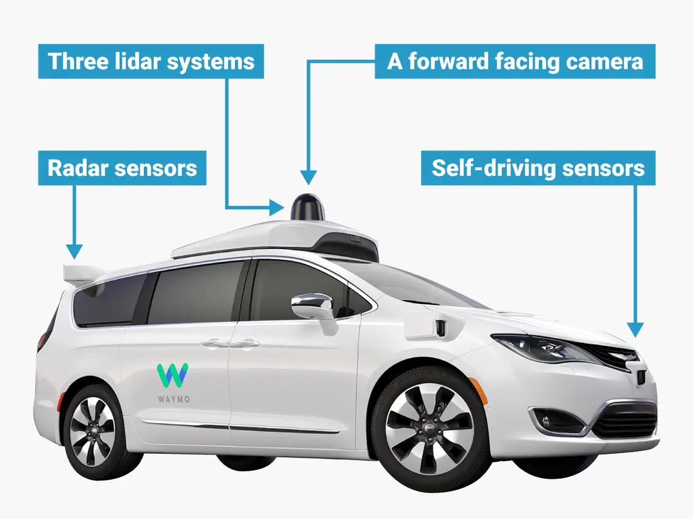

*[Figure 4- Visual of Waymo Driver’s Technology]*

Its cameras, designed with high dynamic range and thermal stability to see in both dayling and low-light conditions, give Waymo Driver a simultaneous 360° view allowing it to spot traffic lights, construction zones, and other objects from hundreds of meters away. Its radar uses millimeter frequencies to provide the Waymo Driver with crucial information like an object's distance and speed, maintaining its effectiveness in rain, fog, and snow. Finally, its onboard computers combine the latest server grade CPUs and GPUs to take in information from the sensors on the car, locate the different objects, and plan the safest route towards your destination in real time.

To dig a little deeper into the decision making process of Waymo Driver’s computers, while they do not explicitly list the machine learning (ML) and deep learning (DL) they utilize, we can infer a few that are potentially used given the technology they use to collect the information. The ones believed to be used are Convolutional Neural Networks (CNNs), Recurrent Neural Networks (RNNs), and Reinforcement Learning (RL). The CNNs, trained to recognize the various objects (cars, pedestrians, etc.), are used to process the data collected from its lidars and cameras. The RNNs model sequential data, like the movement of other objects (vehicles, pedestrians, etc.), in order to predict the trajectories of said objects in its immediate vicinity. Finally, the RL is used to train the model to make decisions that will maximize its reward, which, for Waymo Driver, optimizes its driving behavior over time. These are probably just a few of the various ML and DL techniques they utilize in their autonomous driving technology, but these are ones we inferred given the technology and its uses listed.

The Waymo Driver system is clearly very intuitive and utilizes some advanced technologies in order to make important, safe decisions in real time, but how is the technology tested and reliable? Waymo addresses this in the following statement: *“Testing is the backbone of everything we do. We rigorously put the Waymo Driver through scenarios that are more challenging than what we encounter on the road to validate that it meets our internal safety readiness criteria, and follow all applicable state laws and federal regulations for testing”* (Waymo, n.d.)*.* It is clear that they want consumers to feel comfortable and at ease when using their product, but what exactly is done to test these systems and ensure their safety? Well, Waymo lists 6 different types of field tests it conducts on the product, as well as 7 different backups that ensure the safety of the passenger in case of a software malfunction or failure.

The Waymo Driver system is tested on closed courses, public roads, simulations, crash avoidance, hazard analysis, and reliability & durability. As mentioned previously, Waymo Driver has 20+ million miles on public roads and 20+ billion miles in simulation as testing experience. This includes the closed courses/private test tracks Waymo has with over 40,000 unique scenarios finished, public roads giving the system real world situations to further improve the software, and in simulation, where they can replay/tweak real world scenarios or build completely new virtual scenarios to help identify the most challenging situations the system will face. Waymo has also conducted thousands of crash avoidance tests, recreating specific driving situations in order to analyze the system’s response in situations where other road users create dangerous situations. Their hazard analysis--an analysis of their hardware, behavioral and embedded controls software, vehicle integration, and operations--is a well-established methodology that identifies potential causes of safety risks and either gets rid of or alleviates those hazards before the systems drive in the real world. Finally, the numerous components of the system are exposed to ultraviolet radiation, bombarded with power water jets, corroded in chambers of salty mist, hit by powerful vibrations, and put through intense heat/cold for weeks at a time. This allows Waymo to analyze the parts for any weaknesses and continuously improve their designs over time, ensuring that the Waymo Driver can work well under extreme environmental conditions (Waymo, n.d.).

In regard to system backups, Waymo has implemented many fail safes in case of their system malfunctioning or failing. Waymo Driver has a secondary computer that is always running in the background, designed to bring the vehicle to a stop should the primary system fails. It also has a backup collision detection and avoidance system, where it has the ability to slow or stop the car if the primary system fails. It has a redundant steering and braking system, featuring a secondary drive motor system with independent controllers and separate power supplies, and can bring the vehicle to a safe stop if necessary. Waymo Driver uses independent power sources for each critical driving system, ensuring that the system is up and running during power failures/critical interruptions. It has two redundant inertial measurement systems that cross check each other and will assume control from one another if a fault is detected, ensuring the system can accurately track its motion along the road. Finally, as it is a data and technology company, Waymo has developed a robust process to identify, prioritize, and mitigate cybersecurity threats that align with the industry and government defined best practices, to assure security against potential threats (Waymo, n.d.).

Waymo utilizes an exhaustive decision making process and an extensive array of technology and testing to put the best product they can out into the market, and they seem to hit the mark. Nevertheless, Tesla is the bigger, or more widely recognized, name in the field of autonomous cars--why is that? The biggest drawback to Waymo’s product is the need for comprehensive data before it can be implemented into a major city. As detailed earlier in this section when talking about their process, Waymo needs an extensive overview of a new area, creating an incredibly accurate map, before the system can be released into an area. Furthermore, the system is relatively expensive, as it *“a Chrysler Pacifica Van or Jaguar I-Pace with our censors and computers [costs] no more than a moderately equipped Mercedes S-Class”* (Moreno, 2021) which retails around $180,000 in the United States. In comparison, Tesla’s Self-Driving Beta is a $15,000 add-on to its vehicle, which would be, at the cheapest, ~$65,000 (Tesla, n.d.). However, although their price is much higher than their competitors, they hold claim to a title the competition does not: full autonomy. While the competitors boast their self-driving features, they really only have driver assist capabilities, meaning they still need a human behind the wheel, fully attentive, and ready to take over. Waymo Driver, unlike its competitors, does not need anyone paying attention behind the wheel, in fact the passengers don't even need a license to use it (Waymo, n.d.). This is why, despite its downfalls, Waymo Driver is the superior product to its counterparts.

**3. ‘Regulator’ Role**

When working with self-driving cars, the most important aspect will always be safety, and reliability of the vehicle. Consumers won’t be interested in the technology behind the car, only in whether it is safe and will get them from point A to point B. Comparing the safety of the two companies, Waymo currently takes the lead with their LiDar technology as the company recently shared that its driverless vehicles drove 1 million miles on public roads without any injuries (ABi).

Despite Waymo currently having an advantage in this category, this is still a major area of focus for all companies in the self-driving car industry, in addition to the potential ethical issues that they may face at any split second. In "Self-driving cars face the hard ethical questions humans can’t answer" by Shirin Ghaffary, the author discusses the challenges and ethical dilemmas that autonomous vehicles may face, particularly the Trolley Problem scenario. Ghaffary states that "the Trolley Problem poses a classic philosophical dilemma: If you’re driving a trolley and it’s about to crash and kill five people on the tracks ahead, would you reroute the trolley onto a track with one person instead?" (Ghaffary). This dilemma is particularly important for self-driving cars, as they must be programmed to make ethical decisions in a split second.

The article argues that while humans struggle with such ethical dilemmas, autonomous vehicles must be programmed to make such decisions. According to Ghaffary, "self-driving cars need to be designed with rules for making such choices" (Ghaffary). The article also highlights the potential benefits of autonomous vehicles, including reduced traffic congestion, accidents, and fatalities. Ghaffary states that "self-driving cars have the potential to dramatically reduce crashes and fatalities" (Ghaffary).

However, the article notes that there are still many unanswered questions regarding the ethical implications of autonomous vehicles. Ghaffary argues that "there’s no consensus on how to handle ethical dilemmas involving autonomous vehicles." The article also points out that there are many more ethical dilemmas to consider when it comes to self-driving cars than the Trolley Problem. As such, more research is needed to ensure that autonomous vehicles are developed and operated in a responsible and safe manner.

In the article "Tesla Crash Footage Shows Autopilot Failing to Detect Lane Markings" published by The Intercept, they discuss a recent fatal Tesla crash and the role played by the vehicle's autopilot system. Video footage from the accident shows that the autopilot system did not detect the lane markings and failed to respond appropriately, causing the car to veer off the road and crash.

The article argues that Tesla's autopilot system is not as safe as the company claims it to be and raises concerns about the lack of proper regulation and oversight of autonomous vehicle technology. The article also cites several other incidents involving Tesla's autopilot system, including accidents resulting in deaths and injuries.

The article also highlights the importance of transparency in the development and deployment of autonomous vehicle technology. The authors note that Tesla has not released data on the safety and performance of its autopilot system, which makes it difficult to evaluate the system's effectiveness and potential risks.

Overall, the article provides a critical perspective on the safety and regulation of autonomous vehicle technology, specifically focusing on Tesla's autopilot system. The authors argue that the current approach to regulating autonomous vehicle technology is inadequate and that more transparency and oversight are needed to ensure the safety of drivers and pedestrians.

**4. Winner**

We conclude that Waymo is our winner in the race towards fully automated self-driving cars. One of the main reasons for this is safety concerns surrounding Tesla's approach. While Tesla has made significant progress with its computer vision and object detection technology in recent years, there have been several accidents and fatalities involving Tesla's self-driving cars. Since 2016, the federal agency has [investigated](https://www.kron4.com/news/bay-area/thanksgiving-bay-bridge-crash-may-have-involved-telsa-in-self-driving-mode/) a total of 35 crashes in which Tesla’s “Full-Self-Driving” or “Autopilot” systems were likely in use (Klippenstein, 2023). Together, these accidents have killed 19 people. These incidents raise questions about the safety of Tesla's approach and the potential risks involved in deploying self-driving cars on a large scale without sufficient testing and safety measures.

In contrast, Waymo has taken a slower and more cautious approach, focusing on perfecting their LiDar technology through extensive testing and safety measures. This approach has allowed Waymo to accumulate a wealth of data and experience, which has contributed to their superior safety record. As of February 2023, Waymo's self-driving cars have driven over 1 million miles on public roads with no major accidents or fatalities, a testament to the effectiveness of their approach (Doll, 2023).

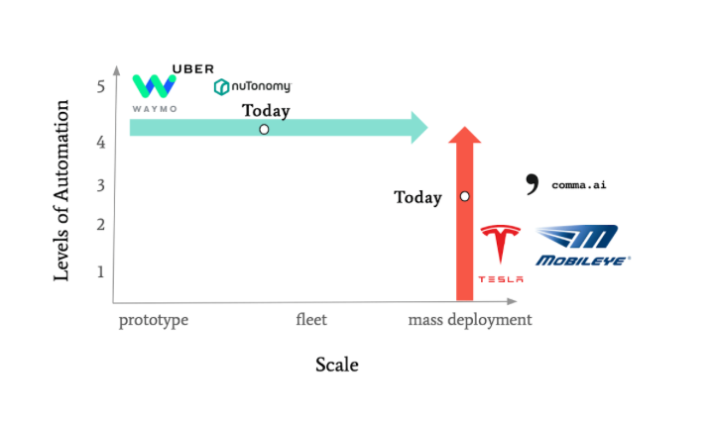

*[Figure 5- Overview of Tesla vs Waymo Approach]*

The above graph summarizes the position of the two companies, and their approaches. Waymo has more advanced automation, waiting for deployment, while Tesla is more widely available with less advanced automation (Fridman, 2018).

In conclusion, while both Tesla and Waymo have made significant progress in the race towards fully automated self-driving cars, Waymo's approach is superior in terms of safety, advanced technology, and industry recognition. As the self-driving car industry continues to evolve, it is likely that Waymo will maintain its position as a leader in the field.

**References**

1. Altman, Alyssa. “The Race to Level 5 Will Be Won Through Collaboration.” Automotive World, 12 Feb. 2021, [www.automotiveworld.com/articles/the-race-to-level-5-will-be-won-through-collaboration/](http://www.automotiveworld.com/articles/the-race-to-level-5-will-be-won-through-collaboration/).
2. Biddle, Sam and Micah Lee. "Tesla Crash Footage Shows Autopilot Failing to Detect Lane Markings." The Intercept, 10 Jan.2023, <https://theintercept.com/2023/01/10/tesla-crash-footage-autopilot/>.
3. Bojarski, Mariusz, et al. "End to End Learning for Self-Driving Cars." arXiv preprint arXiv:1704.07911 (2017).
4. Fridman, Lex, host. "Jack Dorsey: Bitcoin, Ethereum, and AI." YouTube, 7 Feb. 2022, [www.youtube.com/watch?v=dWSbItd0HEA&ab_channel=LexFridman](http://www.youtube.com/watch?v=dWSbItd0HEA&ab_channel=LexFridman).
5. Fridman, Lex. “Emilio Frazzoli, CTO, nuTonomy - MIT Self-Driving Cars” (Mar. 9, 2018). <https://www.youtube.com/watch?v=dWSbItd0HEA&ab_channel=LexFridman>
6. Gama, Mario. "Tesla vs Waymo: Two Opposite Visions." Think Autonomous, 31 Aug. 2021, [www.thinkautonomous.ai/blog/tesla-vs-waymo-two-opposite-visions/](http://www.thinkautonomous.ai/blog/tesla-vs-waymo-two-opposite-visions/).
7. Gardiner, Christian Seabaugh. "Self-Driving Cars: Can You Buy One Now? Here’s What We Know." MotorTrend, 18 Oct. 2021, [www.motortrend.com/news/self-driving-cars-faq-can-i-buy-one/#:~:text=How%20Much%20Does%20a%20Self,the%20%24130%2C000%2D%24150%2C000%20ballpark](http://www.motortrend.com/news/self-driving-cars-faq-can-i-buy-one/#:~:text=How%20Much%20Does%20a%20Self,the%20%24130%2C000%2D%24150%2C000%20ballpark).
8. Ghaffary, Shirin. "Self-driving cars face the hard ethical questions humans can’t answer." Vox.com, Vox Media, 16 July 2021, <https://www.vox.com/recode/22700022/self-driving-autonomous-cars-trolley-problem-waymo-google-tesla>.
9. Hagerty, Mike. "Tesla Full Self-Driving Beta Now Costs $15,000: Here’s Why." Capital One, 28 Nov. 2022, [www.capitalone.com/cars/learn/finding-the-right-car/tesla-full-selfdriving-beta-now-costs-15000-heres-why/1900](http://www.capitalone.com/cars/learn/finding-the-right-car/tesla-full-selfdriving-beta-now-costs-15000-heres-why/1900).
10. Hodgson, James. “Top Autonomous Vehicle Companies.” ABI Research, 9 Mar. 2023, [www.abiresearch.com/blogs/2023/03/09/top-autonomous-vehicle-companies/#:~:text=Mobileye,world%2Dclass%20autonomous%20vehicle%20platform](http://www.abiresearch.com/blogs/2023/03/09/top-autonomous-vehicle-companies/#:~:text=Mobileye,world%2Dclass%20autonomous%20vehicle%20platform).
11. Lambert, Fred. "Waymo and Cruise log over 1 million test miles, will begin driverless rides in Los Angeles." Electrek, 28 Feb. 2023, [electrek.co/2023/02/28/waymo-cruise-1-million-test-miles-will-begin-driverless-rides-los-angeles/.](http://electrek.co/2023/02/28/waymo-cruise-1-million-test-miles-will-begin-driverless-rides-los-angeles/.)
12. Marr, Bernard. "How Tesla Is Using Artificial Intelligence To Create The Autonomous Cars Of The Future." Bernard Marr & Co, 17 Jul. 2020, [www.bernardmarr.com/how-tesla-is-using-artificial-intelligence-to-create-the-autonomous-cars-of-the-future/](http://www.bernardmarr.com/how-tesla-is-using-artificial-intelligence-to-create-the-autonomous-cars-of-the-future/).
13. Mishra, Abhishek. “Decoding the Technology Behind Tesla Autopilot: How it Works.” Artificial Intelligence in Plain English, n.d., <https://ai.plainenglish.io/decoding-the-technology-behind-tesla-autopilot-how-it-works-af92cdd5605f>
14. Moreno, Johan. "Waymo CEO Says Tesla Is Not A Competitor, Gives Estimated Cost Of Autonomous Vehicles." Forbes, 22 Jan. 2021, [www.forbes.com/sites/johanmoreno/2021/01/22/waymo-ceo-says-tesla-is-not-a-competitor-gives-estimated-cost-of-autonomous-vehicles/?sh=6a074d7b541b](http://www.forbes.com/sites/johanmoreno/2021/01/22/waymo-ceo-says-tesla-is-not-a-competitor-gives-estimated-cost-of-autonomous-vehicles/?sh=6a074d7b541b).
15. Nwadike, Ikechukwu. "Tesla’s Self-Driving Algorithm Explained." Towards AI, 14 Oct. 2021, towardsai.net/p/l/teslas-self-driving-algorithm-explained.
16. Perrin, Andrew, and Monica Anderson. "Americans' Attitudes Toward Driverless Vehicles." Pew Research Center, 4 Oct. 2017, [www.pewresearch.org/internet/2017/10/04/americans-attitudes-toward-driverless-vehicles/](http://www.pewresearch.org/internet/2017/10/04/americans-attitudes-toward-driverless-vehicles/).
17. Rangaiah, Mallika. "How Waymo is Using AI for Autonomous Driving." Analytics Steps, 15 July 2021, [www.analyticssteps.com/blogs/how-waymo-using-ai-autonomous-driving](http://www.analyticssteps.com/blogs/how-waymo-using-ai-autonomous-driving).
18. Synopsys. “Autonomous Driving Levels.” Synopsys, 2021, [www.synopsys.com/automotive/autonomous-driving-levels.html](http://www.synopsys.com/automotive/autonomous-driving-levels.html)
19. Tesla. "Compare Tesla Cars and SUVs." Tesla, [www.tesla.com/compare](http://www.tesla.com/compare).
20. Tesla. "Elon Musk." Tesla, [www.tesla.com/elon-musk#:~:text=Since%20the%20company's%20inception%20in,SUV%2C%20which%20launched%20in%202015](http://www.tesla.com/elon-musk#:~:text=Since%20the%20company's%20inception%20in,SUV%2C%20which%20launched%20in%202015).
21. Waymo. "Waymo Driver: Fully Self-Driving Technology." Waymo, [www.waymo.com/waymo-driver/](http://www.waymo.com/waymo-driver/).
22. Xaltius. "Artificial Intelligence in Tesla Vehicles." Xaltius, 7 May 2021, [xaltius.tech/artificial-intelligence-in-tesla-vehicles/.](http://xaltius.tech/artificial-intelligence-in-tesla-vehicles/.)